2018 Pennfield Ultimate Party
Fundraiser

A great cause
and some great food
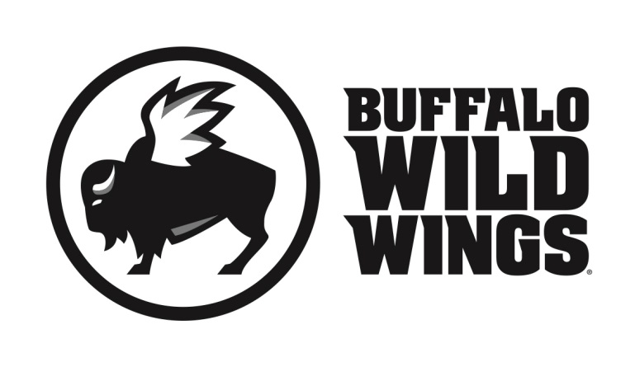

All friends, family and supporters of the 2018 Pennfield Ultimate Party
are invited to participate in their fundraising event on
Sunday, January 28, 2018

Everyone is invited to gather at Buffalo Wild Wings in Battle Creek (5775 Beckley Rd.) for lunch, dinner, or a snack. On this day, 20% of purchases* accompanied by the certificate below will be donated to the
2018 Pennfield Ultimate Party.

2018 Pennfield Ultimate Party Fundraiser
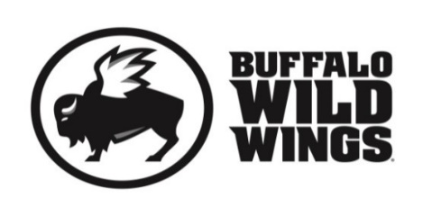
Sunday, January 28, 2018

Present this certificate to your server at the
time of your order and 20% of your
purchases* will go to support the
2018 Pennfield Ultimate Party.
*Valid towards Dine-In and Carry-Out. Not valid towards gift card purchases. Flyers are not permitted to be distributed inside or outside the restaurant.
Only valid at 5775 Beckley Rd., Battle Creek, MI (269) 979-9464

